Practical 2
ARP Protocol & Packet Tracing Using Wireshark

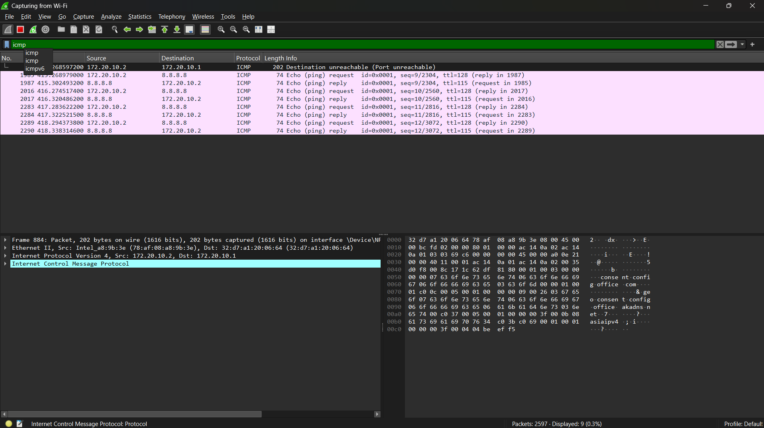
Figure 1 Packet Tracing Using Wireshark

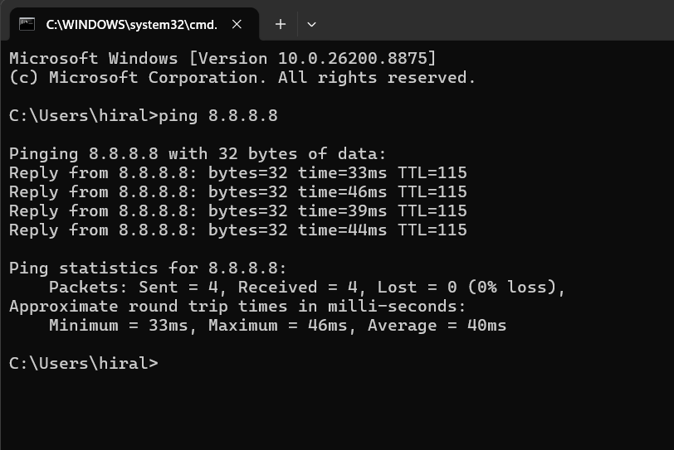
Figure 2 : Ping IP of Google with original terminal

